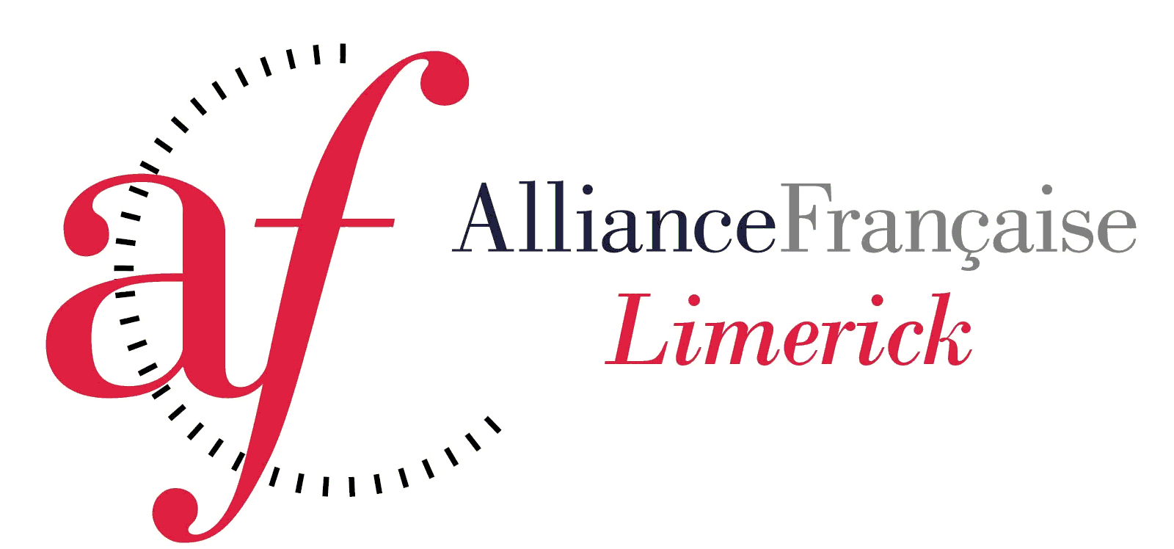

Alliance Française de Limerick Company Limited by Guarantee
7 Pery Square, Limerick : Tel 061 414818
Email : bonjour@aflimerick.org
Website : www.aflimerick.org

Membership of Alliance Française de Limerick Limited
Renewal/Application 2019/20
Alliance Française is a prestigious worldwide organisation. Subscription is available to those interested in the language and culture of France. Suggestions and offers of help for cultural activities are always welcome from members.

Please tick
 | AFL Student |  | € 2
 | Non AFL Student |  | € 10
 | Please tick this box if you would like to get involved in Alliance Française CLG*
 | Family Name
 | First Name(s)
 | Address
 | Telephone Number(s)
 | Email address

Administration Use Only
Receipt No. | Date :

* Student members (under 18 years of age) cannot vote at the AGM of the company

